1. **C program to perform matrix multiplication:**

#include<stdio.h>

void main()

{

int a[10][10],b[10][10],c[10][10],i,j,k,n,m,p;

printf("enter the values of n,m,p");

scanf("%d%d%d",&n,&m,&p);

printf("enter the a matrix elements");

for(i=0;i<n;i++)

{

for(j=0;j<m;j++)

{

scanf("%d",&a[i][j]);

}

}

printf("enter the b matrix elements");

for(j=0;j<m;j++)

{

for(k=0;k<p;k++)

{

scanf("%d",&b[j][k]);

}

}

for(i=0;i<n;i++)

{

for(k=0;k<p;k++)

{

c[i][k]=0;

for(j=0;j<m;j++)

{

c[i][k]+=a[i][j]*b[j][k];

}

}

}

for(i=0;i<n;i++)

{

for(k=0;k<p;k++)

{

printf("%d ",c[i][k]);

}

printf("\n");

}

}

**Output:**

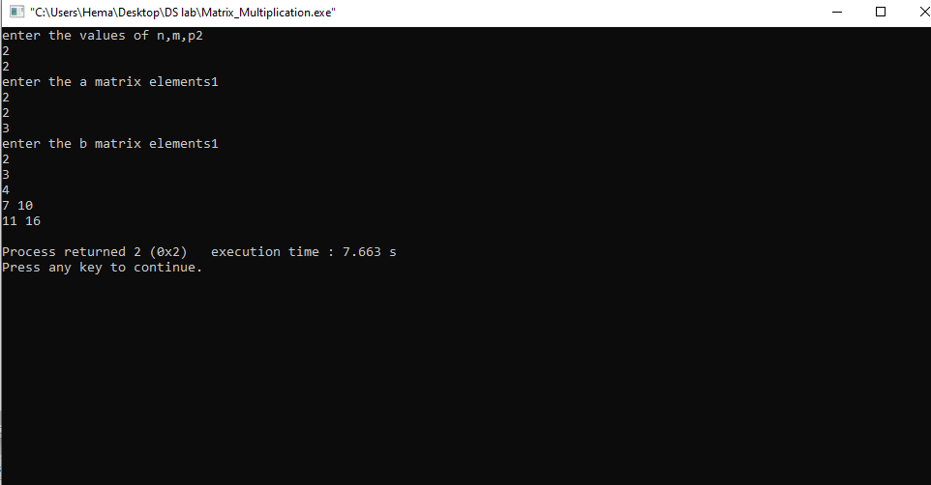

**2.C program to print odd and even numbers in an array**

#include<stdio.h>

void main()

{

int a[10],i,n;

printf("enter the value of n");

scanf("%d",&n);

printf("enter the array elements");

for(i=0;i<n;i++)

{

scanf("%d",&a[i]);

}

printf("even numbers in the array are");

for(i=0;i<n;i++)

{

if(a[i]%2==0)

{

printf(" %d\t",a[i]);

}

}

printf("odd numbers in the array are");

for(i=0;i<n;i++)

{

if(a[i]%2!=0)

{

printf(" %d\t",a[i]);

}

}

}

**Output:**

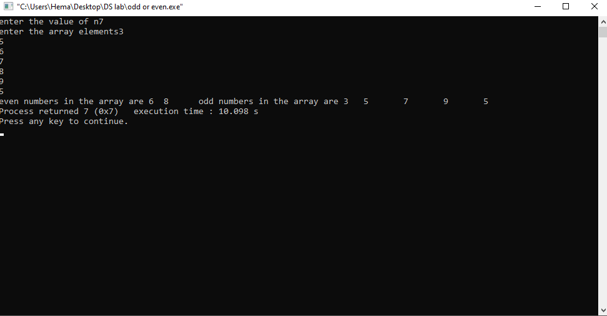

**3. C program to find factorial of a number with out recursion**

#include<stdio.h>

void main()

{

int n,i,fact=1;

printf("enter the number");

scanf("%d",&n);

for(i=1;i<=n;i++)

{

fact=fact*i;

}

printf("%d",fact);

}

**Output:**

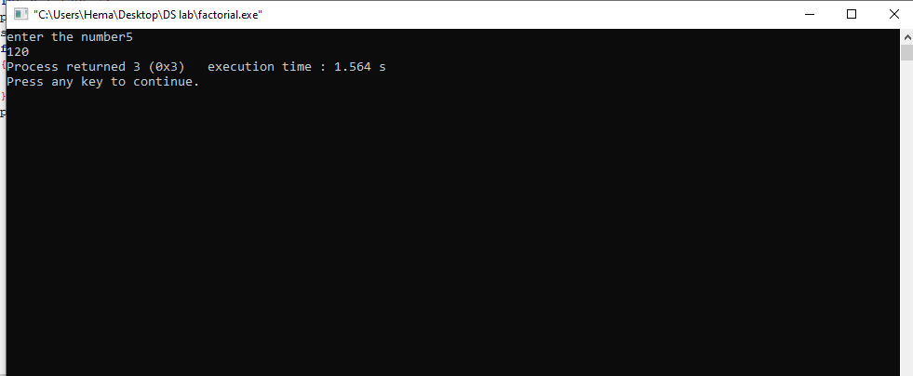

**4.C program to print Fibonacci numbers with out recursion**

#include<stdio.h>

void main()

{

int a=0;

int b=1,n,c,i;

c=a+b;

printf("enter the n value");

scanf("%d",&n);

printf("Fibonacci series %d%d",a,b);

for(i=2;i<n;i++)

{

printf("%d",c);

a=b;

b=c;

c=a+b;

}

}

**Output:**

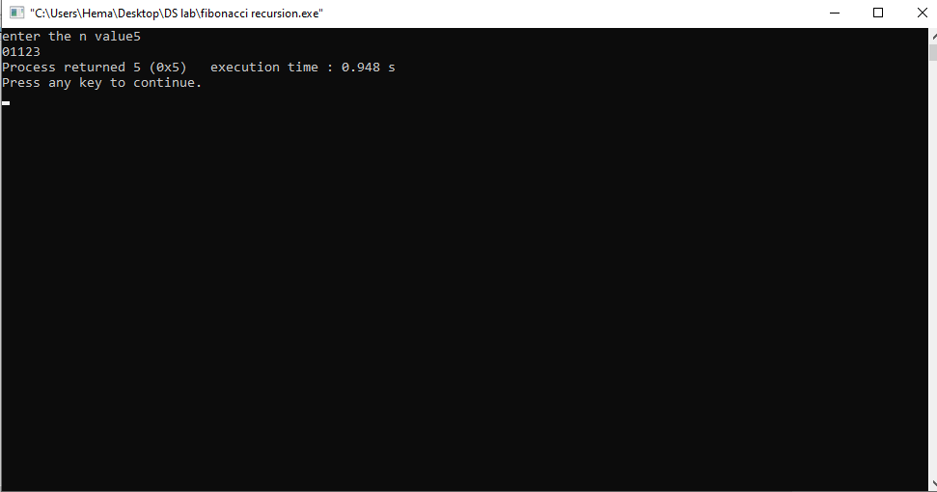

**5. C program to find factorial of a number**

#include<stdio.h>

int facto(n)

{

if(n==1)

return 1;

else

return(n*facto(n-1));

}

void main()

{

int n,fact;

printf("enter the number");

scanf("%d",&n);

fact=facto(n);

printf("factorial of number is%d",fact);

}

**Output:**



**6. C program to print Fibonacci series using recursion**

#include<stdio.h>

int fib(int n)

{

if(n==0)

return 0;

else if(n==1)

return 1;

else

return(fib(n-1)+fib(n-2));

}

void main()

{

int n,i;

printf("enter the n value");

scanf("%d",&n);

for(i=0;i<n;i++)

printf("%d",fib(i));

}

**Output:**

